# **Particle Filter**

This repo implements a particle filter based object tracking algorithm, file test.avi is a demo showing tracking box and particles, our implementation referenced paper [《An adaptive color-based particle filter》](https://www.sciencedirect.com/science/article/pii/S0262885602001294" \t "https://github.com/Lannyy/_blank)

Here is the pesudocode

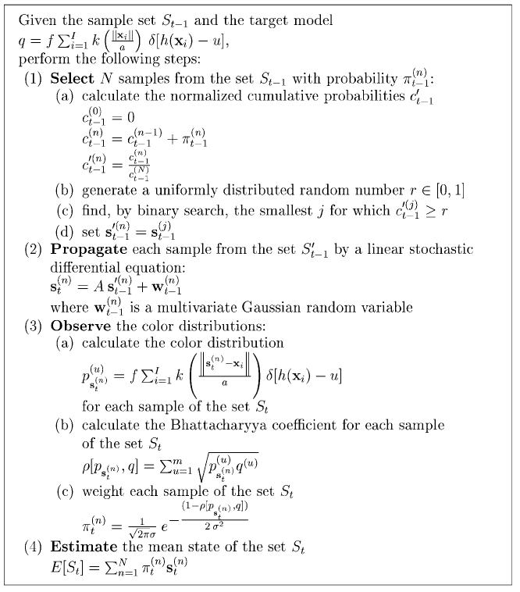

****Prerequisets****

* cv2
* numpy

To run this code, just run main.py like python main.py, this will generate a series of pics in folder output, you can use some scripts to transform these pics into a video

You can tune parameters in file ParticleFilter.py, like particle nums, Gaussian distribution's params and color histogram's params etc.

Here is one frame in the tracking process

[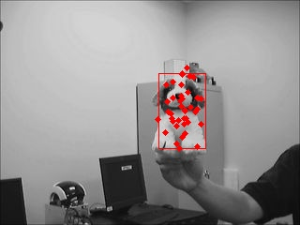](https://github.com/Lannyy/particle-filter/blob/master/demo.jpg)

